

***EASY HOSPITAL***

***Project final report***



Daffodil International University

Course Title : Object and Oriented Programming-Lab

Course Code : CSE-215

Submitted to:

Ahmed Al Marouf

Lecturer of Daffodil International University

Department of CSE.

April 17, 2017

Submission date :

***Our Group Members***

*Name ID*

**Koushik Sarker Antu 161-15-7317**

**Majedul Islam Rifat 161-15-6784**

**S.M.Irfan Rana 161-15-7073**

# Project Title: “*EASY HOSPITAL*”

# Introduction:

This is a java application named “EASY HOSPITAL”. The people of all classes can use our application. This chapter highlights the result of the project and the snapshots for each of the activities are shown along with the discussion of each activity describing its working. Each snapshot describes every single step of the easy hospital application. Two main activities as well as options provided to the users in each activity such as menu options and the activities which are created on the click of these options are also shown and described in brief. Using this application people can find information of hospital as well as can save information of doctors and specialist. User also can store information of any doctor. it will be one of the best advantages of this application is that users even have all of the dental hospitals, apart from the medical health care centers, and users get the options to call the phone number given in the listing. i.e. user don’t need to type in the phone number by noting it down, but users can just click on the button and it would initiate the call. There aren’t always the same times when users would not be able to go to hospital for emergency, and would need to rely on the applications. The Easy Hospital app could be the best help in such cases.

**#** Objectives:

The objective of developing such as application for finding a hospital in an easy way and safe of time in to get a better treatment. There by increasing the efficiency and decreasing the time complexity. The project provides us the information about hospital records, various faculties and some important information of some doctors whose user want. The application must provide the flexibility of generating the required documents on screen.

# Motivation:

As a user of android applications we have been interested in this field since our interest in computing began. Our own experiences of using android application in medical section has led us to ponder many questions as to why there are so many android applications for finding hospital and getting treatment in an easy way. This project has given us the opportunity to explore the world of android application to find out the answers to our questions.

Our knowledge of this field at the start of the project was casual.

# The Main Features:

The main features of our application are as follow,

1. Application icon: Our application has a nice icon. It’s a white circle having a red color plus sign in the middle.
2. Login page: There will show a login page to the users. If any user want to use this application then they must login first.
3. Home page: After login users can see a home page. Where they will be two options for the users. One is the list of all hospital saved by the user and the other one is all information of doctors which also saved by the user.
4. Hospital List: In this option there are some information about the hospitals.

i.e. * Name

* Phone no.

* Category

This information can be update and it only depends on user.

b) Doctor Information: In this side there are also three options.

1. Doctor List: Here user can save some doctor information. They can update and remove all information. Here there is a special feature and that is calling option.

2. Add Doctor: Here user can save new doctor’s information.

3. Home: There is also a home button. User can go to home page from this page by clicking this button.

# Special Features:

There are also some special features here. Those are make the application easer to the users.

1. Creating an account: To use this application user must have to create an account and then they can login. It will keep this application secure.
2. Calling option: That is another special feature of this application. It is a button option. By clicking this button it will make a phone call to the doctor which one you want to call.

# Working Flow Diagram:

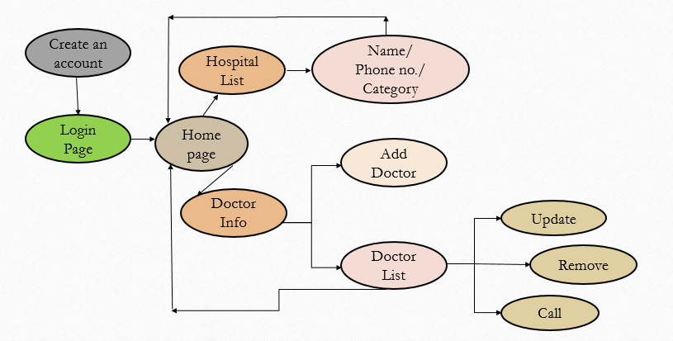

# Implementation & Software Requirements:

It is an android application. To extract this application we had to used some tools, operating system.

Used smartphone or computers for functions they used to need a cellphone. Smartphone and computer combine both computing and communication features in a single device that can be held in a hand or stored in a pocket, allowing easy access and use at the point of care.In addition to text, new mobile device models offer more advanced features, such as high-quality cameras. With these features, as well as powerful processers and operating systems, large memories, and high-resolution screens, mobile devices have essentially become handheld computers. Android studio for compiling codes.

# Demonstration (Screen shots):

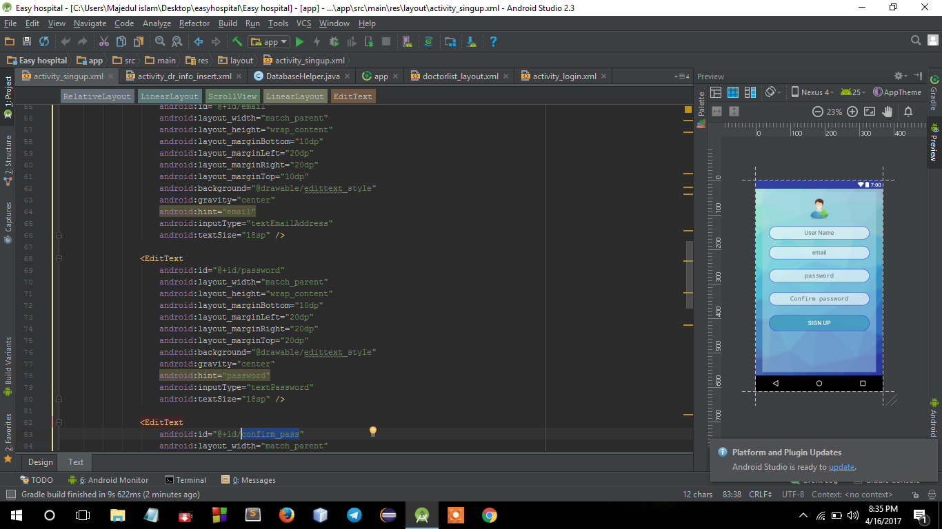

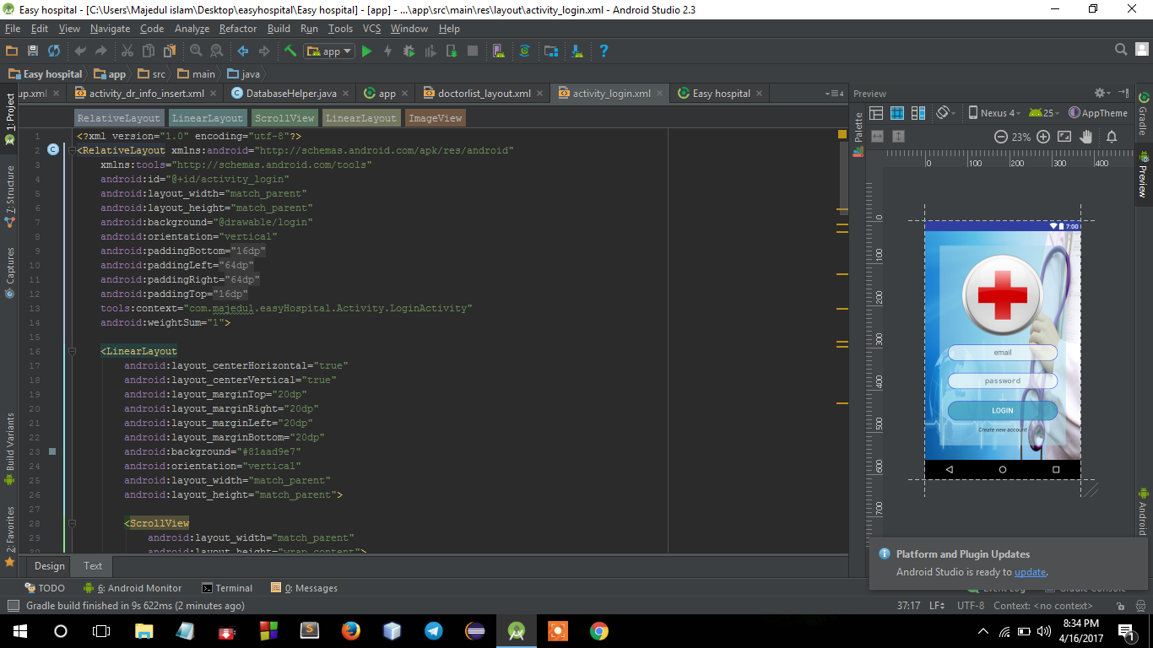

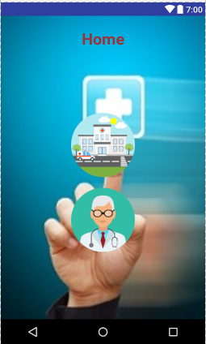

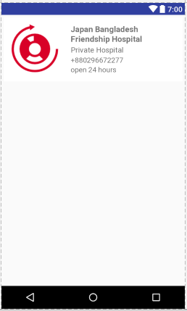

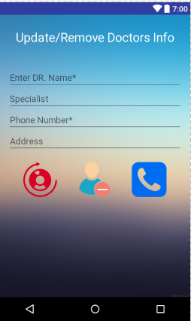

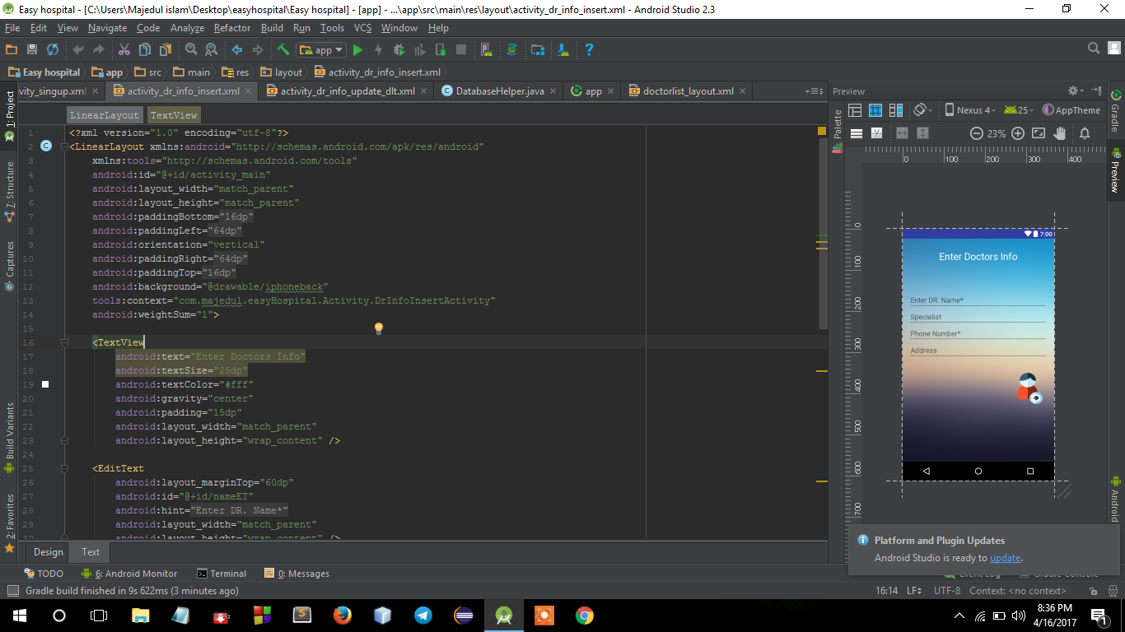

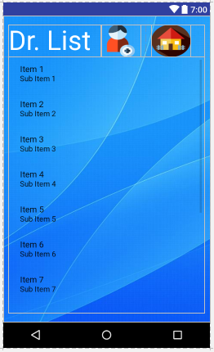

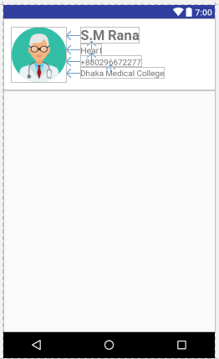

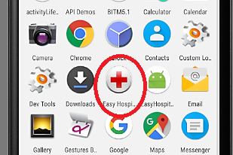

# Future Prospective:

In future we will implement some another features like as GPS, map, ambulance service, online booking, adding prescription picture, searching option etc.

# Conclusion:

This is a very important application. It will help people to get any medical service easily. It will reduce tension of people to finding hospital and doctor with a huge time. It will make a patient very closer to hospital and doctors. So we hope everyone will like our application and use it with satisfaction.

# Project Team Contribution:

We are three members in our project group. We all worked to establish this application. Here given a pie Chart to show each members contribution.

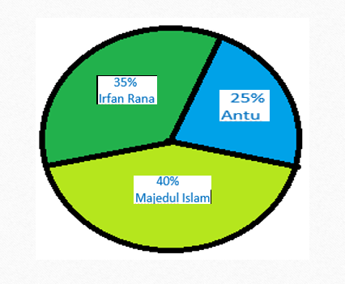

# Reference:

Sir Ahmed Al Marouf

1. https://www.javatpoint.com/

2. https://www.google.com/?gws_rd=ssl#q=tutorialspoint+java

3. https://www.youtube.com/results?search_query=java+projects+hospital

4. https://developer.android.com/index.html